Q1)

#include<iostream>

using namespace std;

class MyClass {

public:

int rollno;

int phone;

string address;

};

int main() {

MyClass mary,adam;

mary.rollno = 1;

mary.phone=1243354215;

mary.address="china";

adam.rollno = 2;

adam.phone=5786357824;

adam.address="japan";

cout << mary.rollno<< "\n";

cout << mary.phone<< "\n";

cout << mary.address<< "\n";

cout << "\n"<<adam.rollno<< "\n";

cout << adam.phone<< "\n";

cout << adam.address<< "\n";

return 0;

}

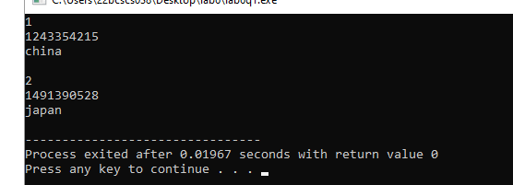

Q2)

#include<iostream>

using namespace std;

void area(int b,int h);

void perimeter(int a,int b,int c);

class triangle {

public:

void area(int b,int h){

cout<<"\n"<<"area="<<((b\*h)/2);

}

void perimeter(int a,int b,int c){

cout<<"\n"<<"perimeter="<<a+b+c;

}

};

int main() {

triangle obj;

obj.area(3,4);

obj.perimeter(3,4,5);

return 0;

}

